1. МДК.05.01 Практикум по фонетике, устной и письменной речи
2. Преподаватель: Нугаева Л.Р.
3. Название темы: Люди и их характеры (4 ч.)

4. Задание:

1. Перевести текст
Just like every person, my character is flawed. I have strong points in my personality, but there are also things that are bad and need to change.
The trait that stands out the most in me is my stubbornness. It can both help me and do me harm. For example, it’s pretty beneficial when there’s something very difficult I need to do — in this case, I won’t stop until I’ve reached my goal. Sometimes this turns against me, as I may pay too much attention to one particular and completely forget about everything else around me. My hobby is drawing, and once I was so determined to finish a piece i’d been working on for a long time that I didn’t sleep for 40 hours. I ended up dozing off and spilling red paint all over it, so I had to redo everything again.
According to my friends, another signature trait of mine is my friendliness. Most will say that this is a good character point, but it brought disadvantages, too. I’ll volunteer to help with things I don’t really have time or will for, solely because no one else wants to help. And then I either end up breaking my promises or nearly cry because I’m exhausted from managing both tasks I need for myself and things that I’m doing for others.
Overall, I wouldn’t say I’m particularly good or bad — there are certainly things I need to work on, and I have no shame admitting that.

2. Разгадать кроссворд
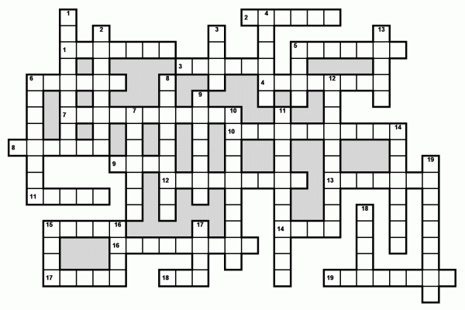

Down:
- This person doesn't like to share information with other people.
- This person is always pleasant and helpful towards other people. He easily makes friends.
- This person is boring. He is not intelligent.
- This person doesn't tell lies and he never cheats.
- This person is pleasant, people like him.
- This person is happy and energetic.
- This person is able to wait for a long time without getting angry.
- This person doesn't feel shy or frightened. He believes in his own abilities.
- This person doesn't care about other people. He thinks only about himself.
- This person thinks about other people and considers their needs to be important.
- This person likes doing new and exciting things and going to unusual places.
- This person behaves in an angry way, often argues with people or attacks them.
- This person doesn't talk much and doesn't make much noise.
- This person likes sharing things and giving presents to other people.
- This person is relaxed. He doesn't get excited or show strong emotions.
- This person doesn't like to work.
- This person is clean and always puts things away in the right places.
- This person is not afraid of difficult or dangerous situations. He is courageous.
- This person easily understands other people's emotions.
Across:
- This person is interested in everything that happens around him, and wants to find out about different things.
- This person enjoys talking a lot in a friendly way.
- This person behaves towards others in a pleasant way and doesn't forget to say "please" and "thank you".
- This person enjoys being with other people.
- This person feels worried or anxious and easily gets excited. He doesn't feel relaxed.
- This person is good at learning and understanding things.
- This person likes doing things on his own. He doesn't like asking for help.
- This person wants more money, things, or power than he needs.
- This person cares about other people and wants to help them.
- This person puts a lot of effort into his work.
- This person supports his friends even in difficult times and never betrays them.
- This person doesn't often worry and never really gets angry.
- This person always says what he really means. He isn't double-faced.
- This person is impolite. He tries to offend other people by his speech or behavior.
- This person enjoys causing pain to other people or making them unhappy or upset.
- This person is determined to become successful, rich, famous, etc.
- This person often becomes unhappy or angry for no particular reason.
- This person doesn't like meeting new people and hates going to parties.
- This person has a lot of imagination and new ideas.
Если Вы хотите разгадать кроссворд онлайн, зайдите на сайт http://time4crosswords.webtm.ru/crosswords/crossword_d017_character.php
5. Итоговую работу сдать до 18.05.2020 г.

