1. Дисциплина: Иностранный язык (английский)
2. Преподаватель: Нугаева Л.Р.
3. Название темы: Система образования Канады, Австралии, Новой Зеландии (4 ч.)

4. Задание:

Прочитайте и переведите тексты «Education in Canada» и «Education in Australia» (устно), изучите схемы.

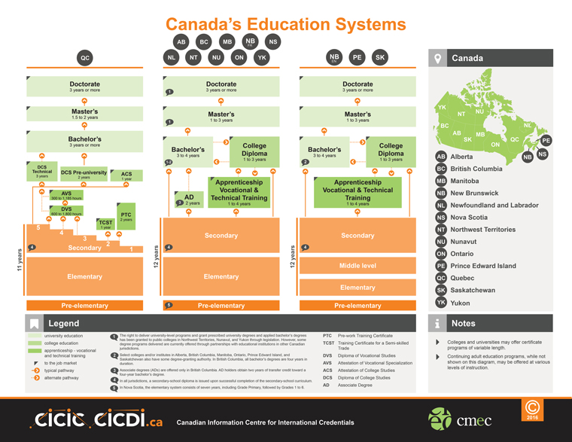

Education in Canada
The school system of Canada is very much like the one in the USA, but there are certain differences. Education in Canada is general and compulsory for children from 6 to 16 years old, and in some provinces — to 14. It is within the competence of the local authorities, and therefore it may differ from province to province. For example, Newfoundland has an 11-grade system. Some other provinces have 12-grade systems, and Ontario has even a 13-grade system. Grades 1—6 are usually elementary schools, and grades 7—12 are secondary schools. In some provinces there is a kindergarten year before the first grade. Elementary education is general and basic, but in the junior high school years the students can select some courses themselves. Most secondary schools provide programmes for all types of students. Some of them prepare students for continuing their studies at the university. Vocational schools are separate institutions for those who will not continue their education after secondary schools. There also exist some commercial high schools. Some provinces have private kindergartens and nursery schools for children of pre-elementary age. There also exist Roman Catholic schools and private schools in some provinces. In most provinces private schools receive some form of public support. Admission to the university in Canada is after high school with specific courses. Getting a degree in law, medicine, dentistry or engineering usually takes 3—4 years of studying. University tuition fees vary among different provinces. All provinces also have public non-university institutions. They are regional colleges, institutes of technology, institutes of applied arts, colleges of agricultural technology and others. Criteria for admission to these institutions are less strict.

EDUCATION IN AUSTRALIA
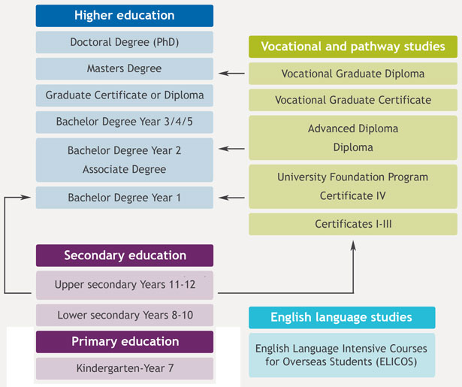

Education in Australia
There exists a centralized national system of education in Australia.
The top of this system is the Federal Ministry of Education. But there are still many differences in the structure and the curricula of schools in different states. There exist two types of schools in the country: state schools and private schools. Tuition in state schools is free of charge. Private schools charge rather high fees. 80 % of Australian children go to state schools, and only 20 % attend feepaying schools.
School education is obligatory for all children from 6 to 15 years. At present the school education scheme is “6+4+2” or “7+3+2”. Most children begin primary schools at the age of about five. Primary schools include from 1 to 6 or 7 grades. After the primary school children pass to the secondary school without examinations. Junior high schools comprise 4 or 3-year courses. After these courses students complete two year senior high school.
After senior classes of secondary schools students may enter any higher educational institution in the country. There is a tendency of cancelling final examinations in both junior and senior secondary schools. In this case more children, irrespective of their abilities, may receive secondary education. University admission is only after the senior secondary schools. Tuition fees differ from one state to another.

Заполните сравнительную таблицу:

Education in Canada | Education in Australia

Дата сдачи работы 13.11.2020

Выполненное задание отправить на почту bor-lili@rambler.ru или на Viber по телефону 8-919-831-18-49

